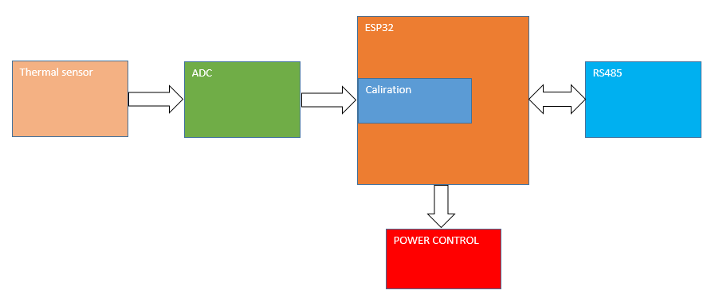
- The thermocouple device can communicate with the control device with RS485
- The thermocouple device can control the power input. When the ADC is sampling data, the MCU will disconnect the power input. And the thermocouple will powered by the battery.
- The thermocouple device feedback the sample data to the control device per second.
1.COM configuration：
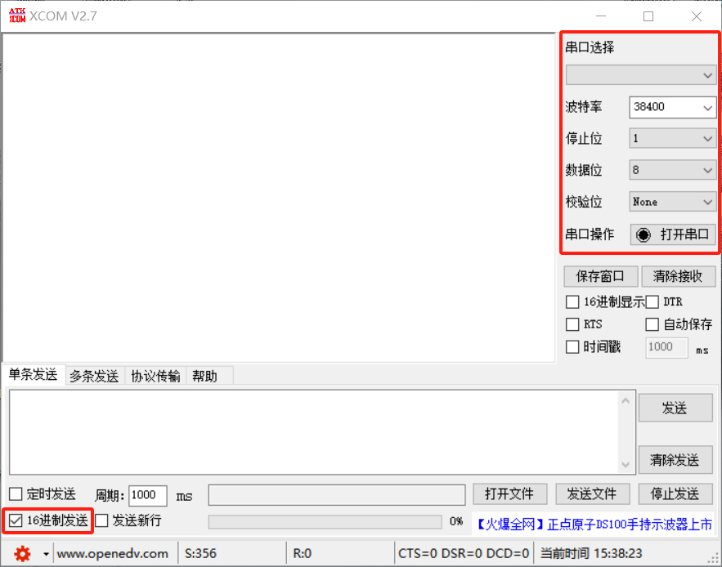
- Select the COM port
- Baud rate 38400
- Stop bit 1
- Data bit 8
- Calibration bit None
2.Thermal control command：
- Sample start command：24 09 00 00 41 01 4B 0D 0A
Sample stop command：24 09 00 00 41 00 4A 0D 0A
Sample control reply command ：24 08 00 57 61 C0 0D 0A
When the thermocouple device receive the sample start command from the control device, the thermocouple device starts ADC sampling.
When the thermocouple device receive the sample stop command from the control device, the thermocouple device stop ADC sampling.
When the thermocouple device start or stop ADC sampling, it will transmit the feedback command to the control device.
- Start sample control command
NO. | Data | Bytes | Description | Data type | remark
1 | Start ID | 1 | 0X24 | UChar
2-3 | length | 2 | 0X0009 | UShort
4 | Sender ID | 1 | 0X00 | UChar
5 | CMD | 1 | ‘A’（0X41） | UChar
6 | control | 1 | 0x01 start sample  0x00 stop sample | UChar
7 | check sum | 1 | Check sum of 2-6 bytes | UChar
8-9 | End | 2 | 0X0D and 0X0A | UChar
- Start sample control feedback command
NO. | Data | Bytes | Description | Data type | remark
1 | Start ID | 1 | 0X24 | UChar
2-3 | length | 2 | 0X0008 | UShort
4 | Sender ID | 1 | ‘W’（0X57） | UChar
5 | CMD | 1 | ‘a’（0X61） | UChar
6 | check sum | 1 | Check sum of 2-5 bytes | UChar
7-8 | End | 2 | 0X0D and 0X0A | UChar

- Temperature data feedback command：24 0B 00 00 62 00 00 00 00 57 0D 0A
When the thermocouple is in sampling status, it will transmit the temperature data to the control device per second。
- Temperature data feedback command
NO. | Data | Bytes | Description | Data type | remark
1 | Start ID | 1 | 0X24 | UChar
2-3 | length | 2 | 0X000B | UShort
4 | Sender ID | 1 | ‘W’（0X57） | UChar
5 | CMD | 1 | ‘b’（0X62） | UChar
6-9 | temperature | 4 |  | UChar
10 | check sum | 1 | Check sum of 2-5 bytes | UChar
11-12 | End | 2 | 0X0D and 0X0A | UChar

